Computer Networks

Lab Task #7

Saad Ahmad

20P-0051

Task#1

Add 4x Laptops, 1x Access point and 1x Server.

Connect them with cables.

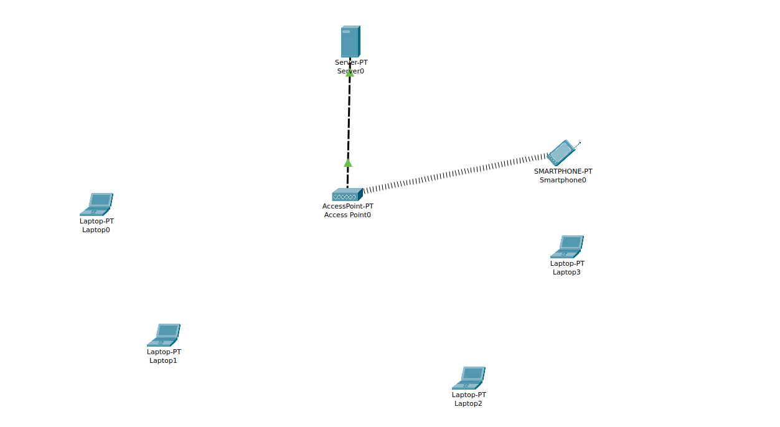

Now assign the static IP to the DHCP Server

**IP:** 192.168.1.2

**Subnet mask:** 255.255.255.0

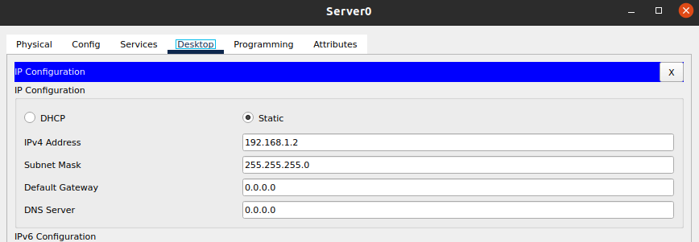

And now create the pool in DHCP

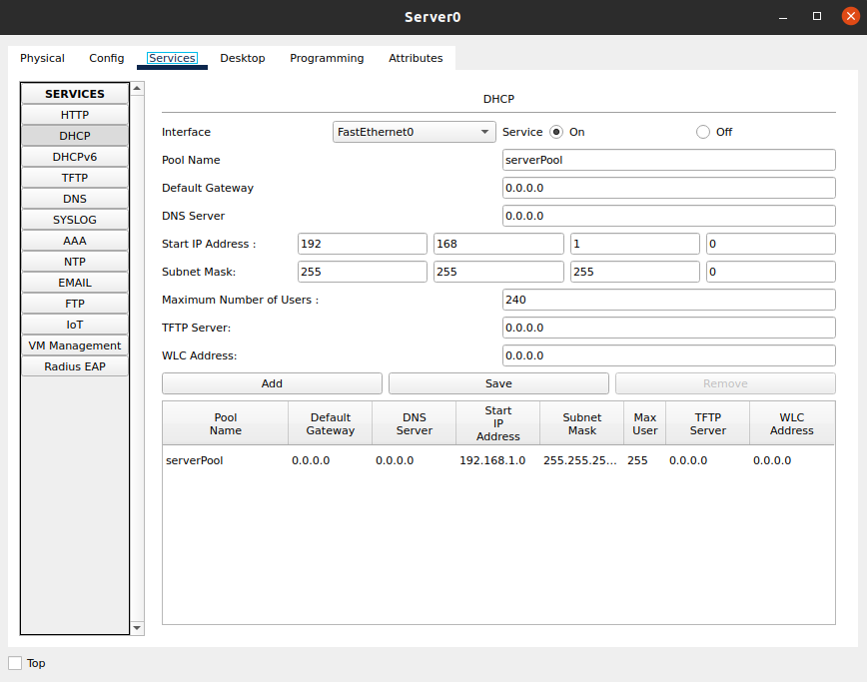

**Placing the Wireless Interface Card to the Laptops:**

Turn off the laptop and remove the classical Ethernet and instead of it place Wireless Interface Card (WPC300N) and then power on the laptop again.

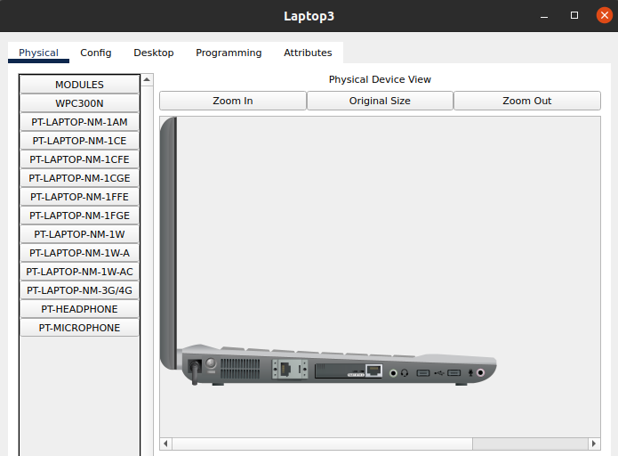

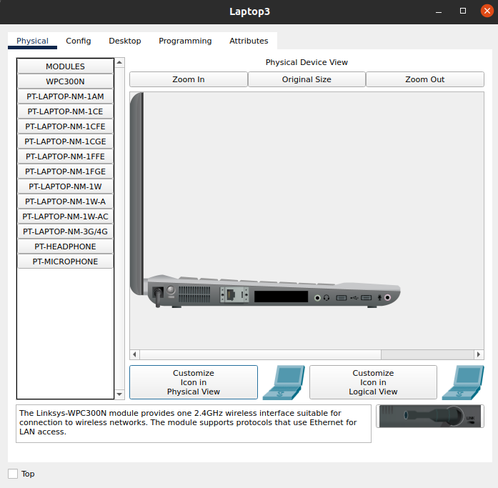

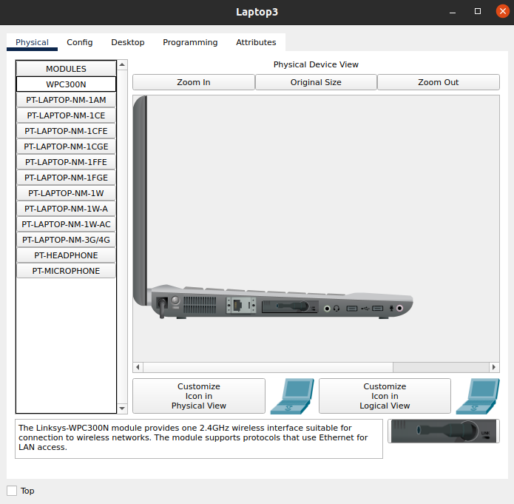

**Do this for all the remaining laptops.**

Now the assign the laptops IPs using the DHCP pool which we had created.

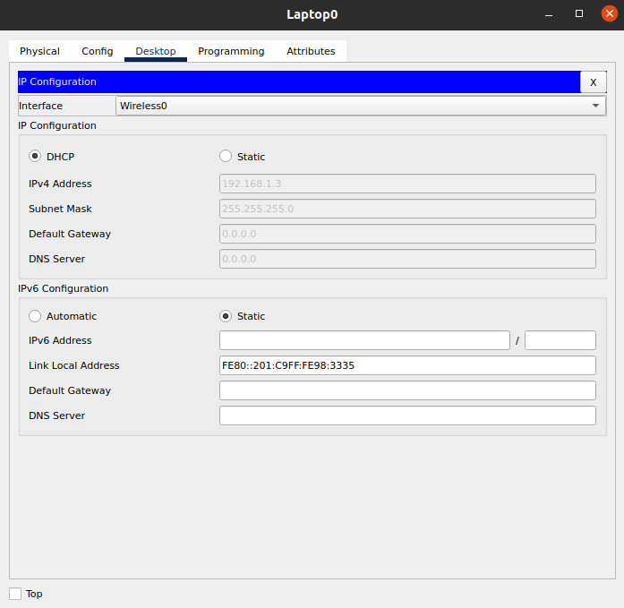

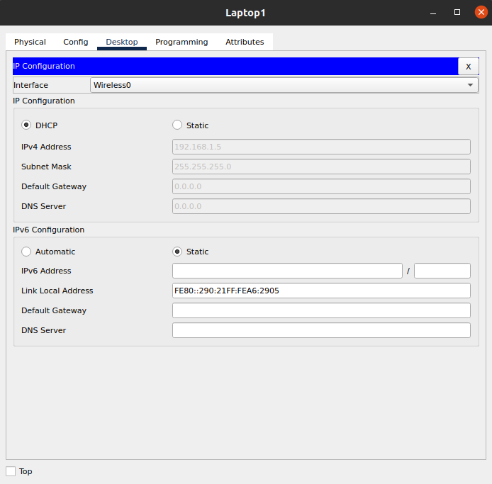

And now ping the laptop to check the connection.

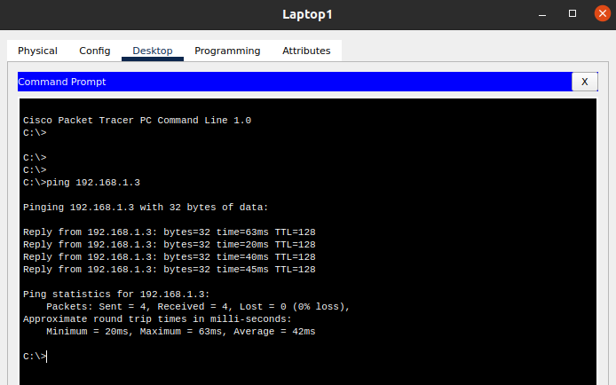

Task #2

Add 2x Laptops, 1x PCs, 1x Wireless Router, 1x Router and 1x Server.

Connect them with cables.

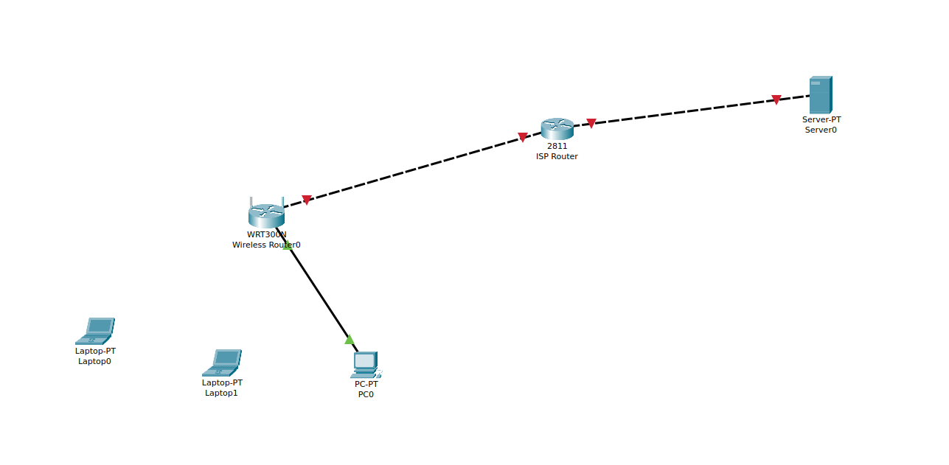

**Placing the Wireless Interface Card to the Laptops:**

Turn off the laptop and remove the classical Ethernet and instead of it place Wireless Interface Card (WPC300N) and then power on the laptop again.

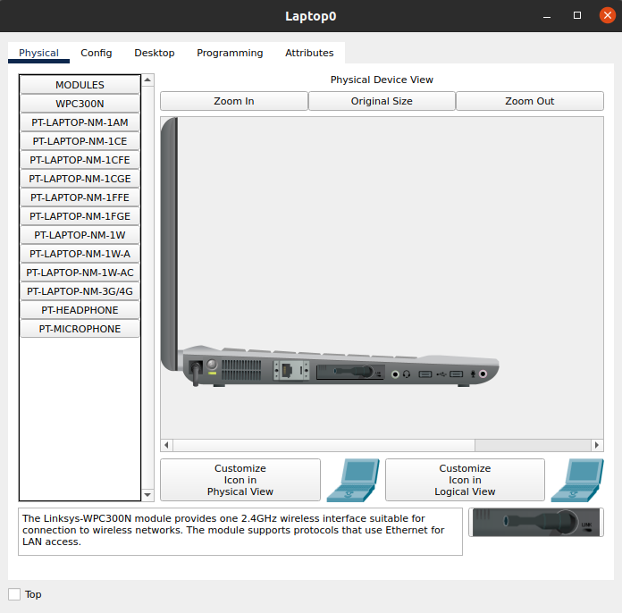

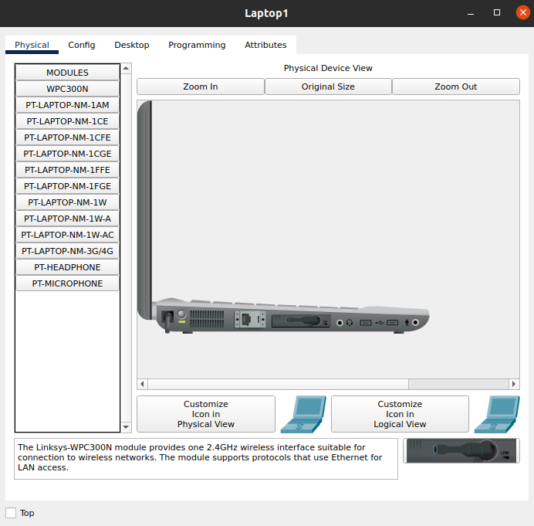

Next, we’re going to do some settings on the wireless router to create a LAN then connect it to the internet.

So, for that go to the admin PC and open the browser and type the IP in the address bar

**IP:** 192.168.0.1

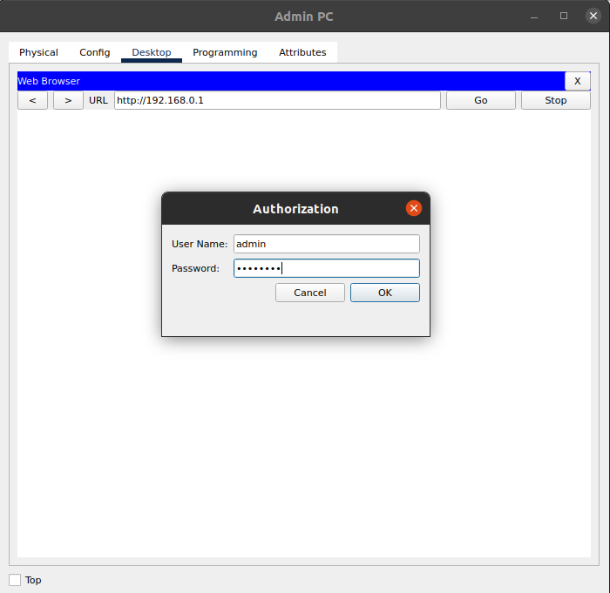

And now you will see the following window

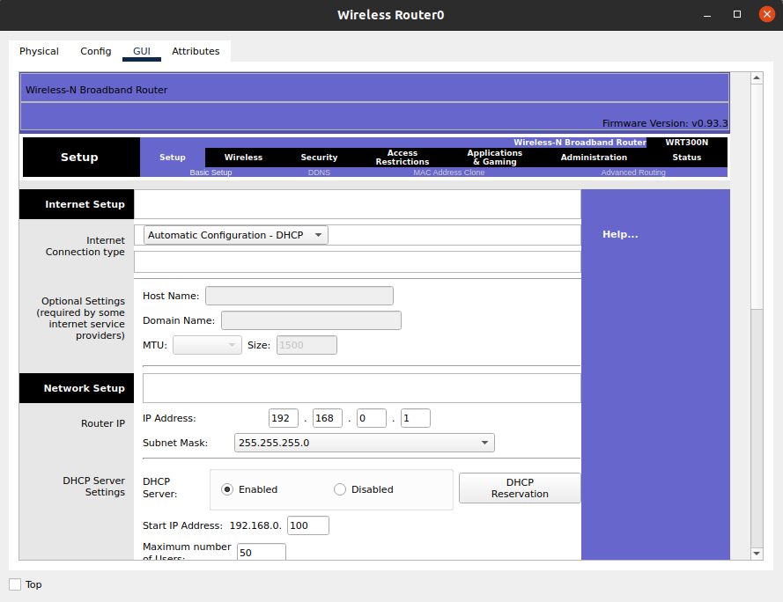

And now assign the IPs to the laptops:

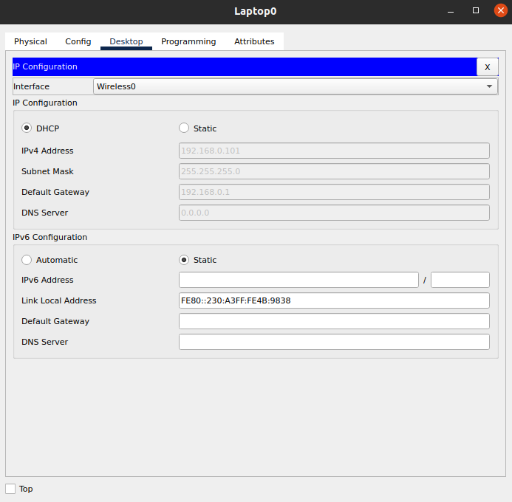

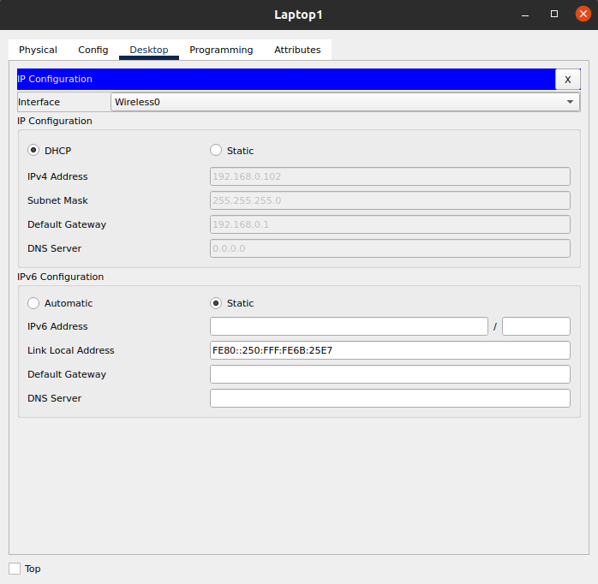

Now by default the router password is admin so we can change it in the Administration tab

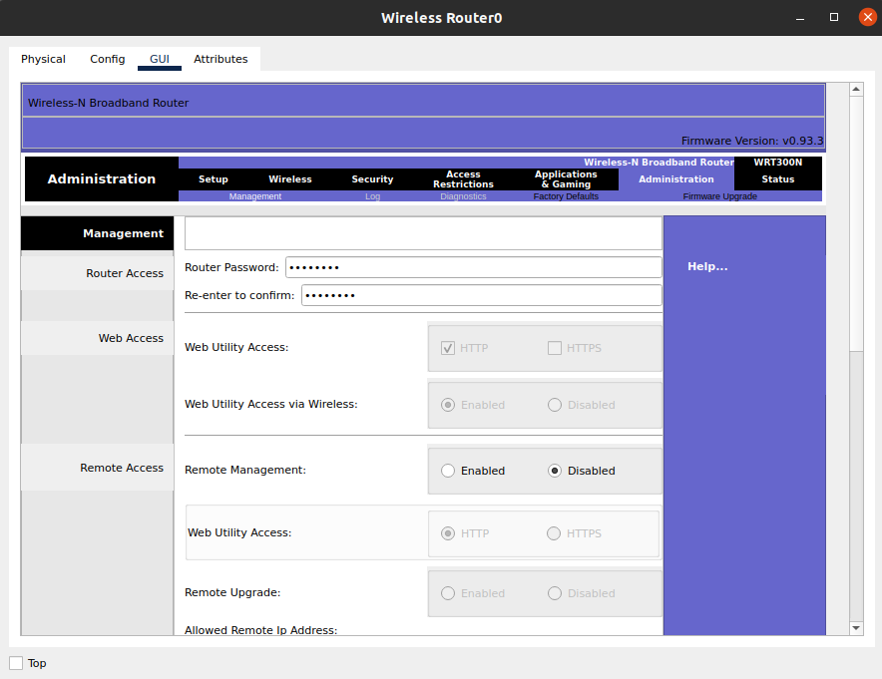

Plus, we can change the DHCP server setting in the wireless router under the setup tab:



Now to check the connection between the two laptops:

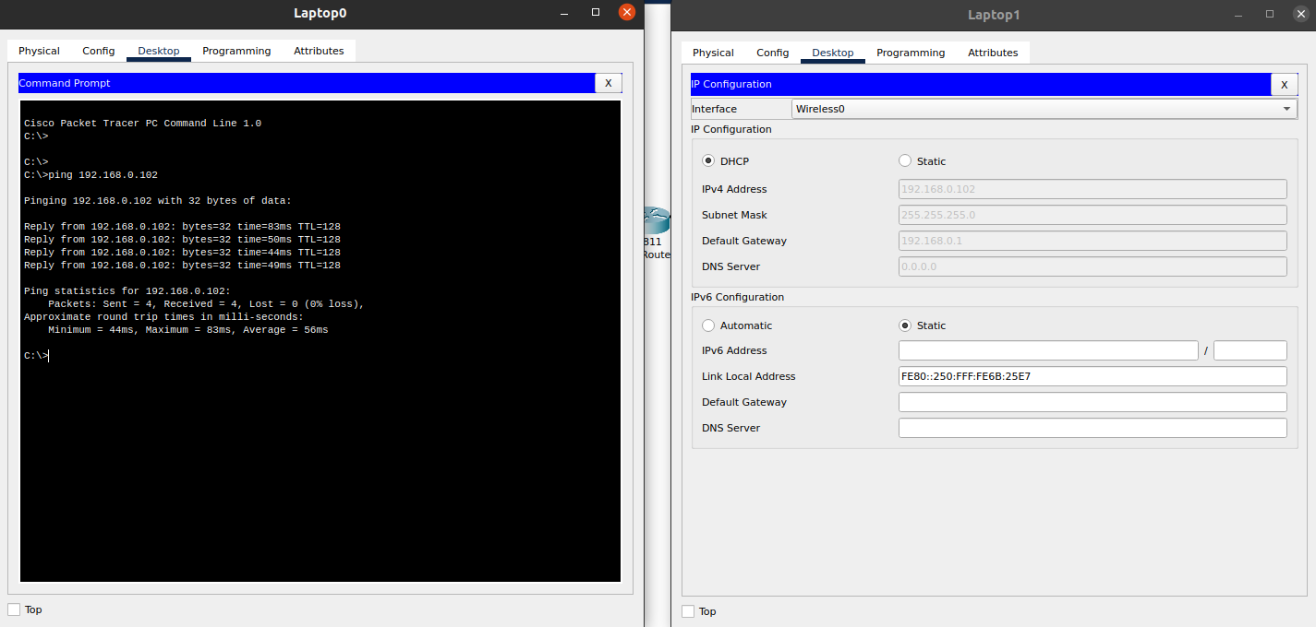

we can also change the name of our Wi-Fi and add the security to our network:

go to the wireless setting and change the SSID and go to the sub tab of wireless setting and select wireless security and select the security mode WPA Personal and then add the Passphrase:

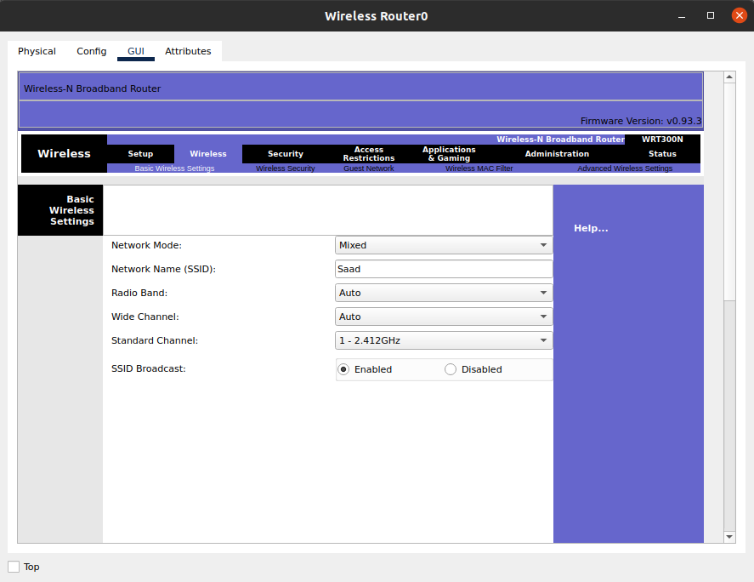

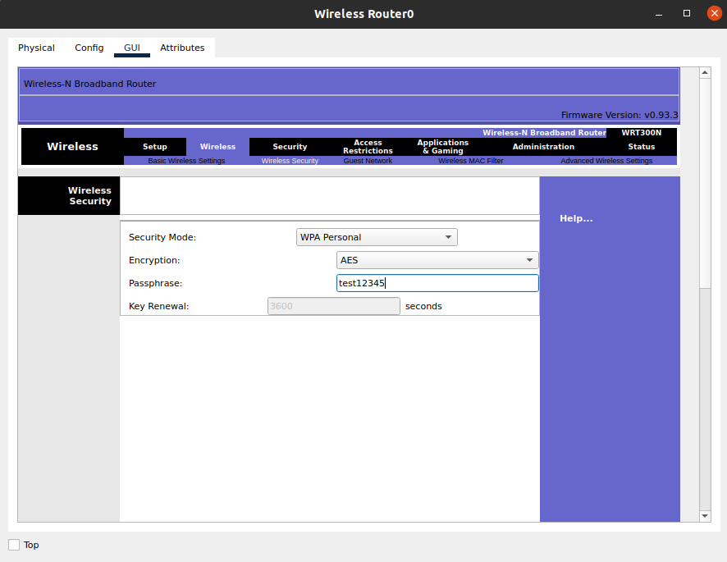

As we have added the security to our network now go to the laptop and select PC Wireless and select the connect tab and there you will see you network name:

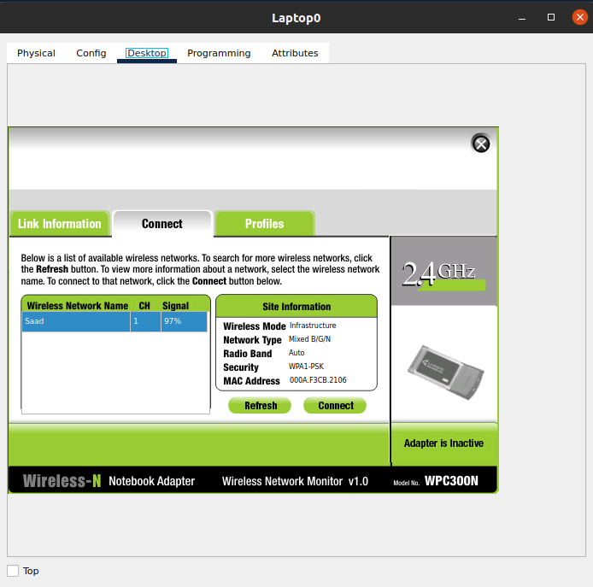

Now select the network and click on connect and then enter your password:

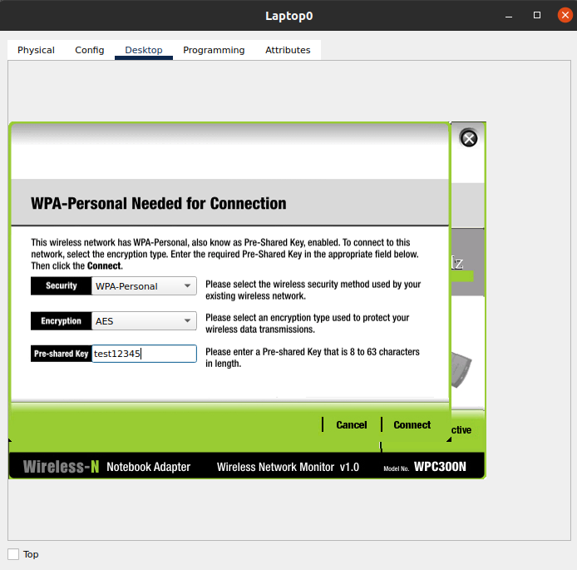

and now we will configure our router:

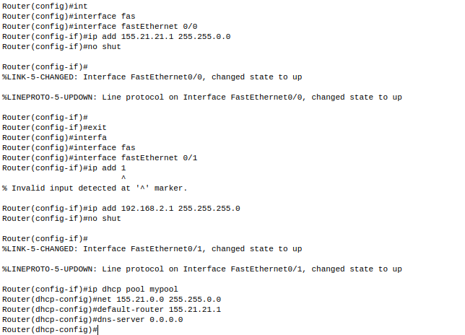

assign the static IP to you sever:

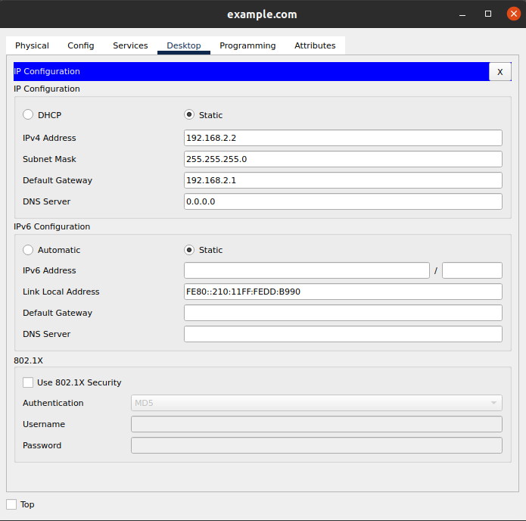

and finally, we will check the connection whether it work or not so for that ping the server from laptop:

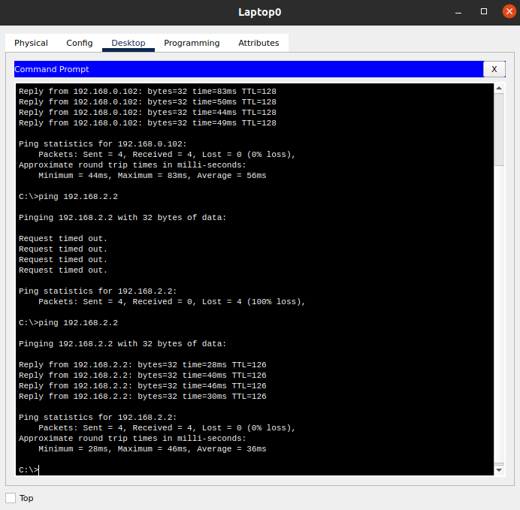

**Ta da it’s working.**